**KẾT QUẢ CHO CÁC BÀI TẬP**

2.2.1

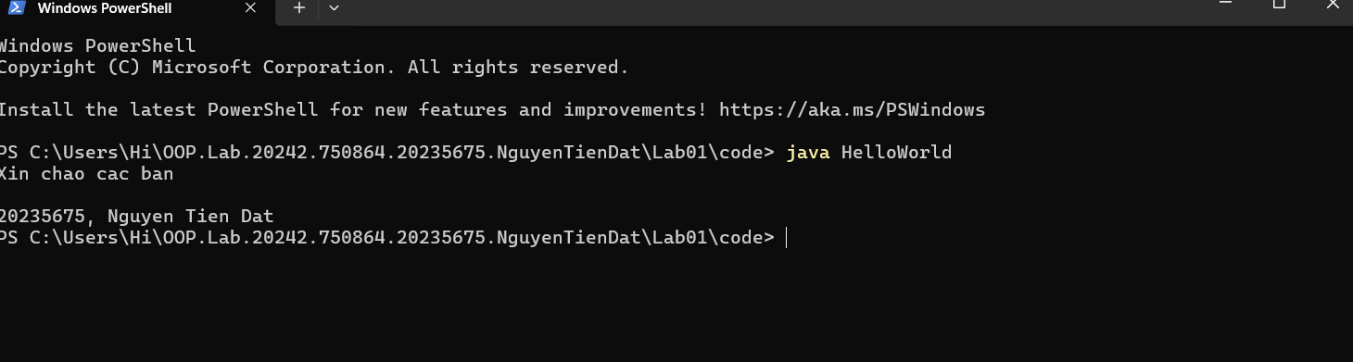

2.2.2

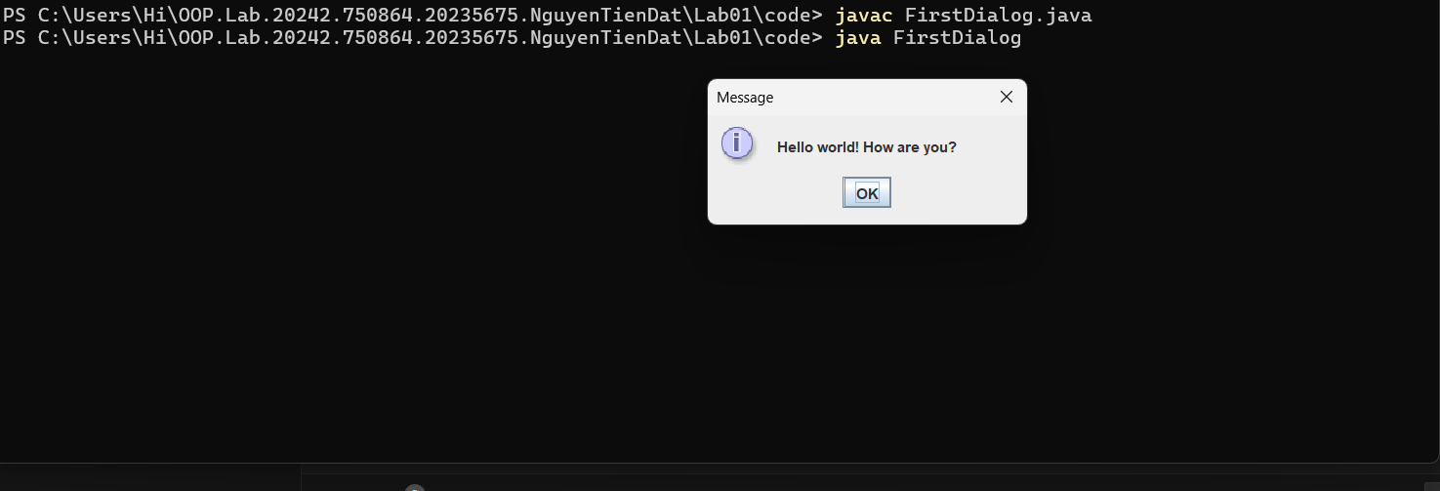

2.2.3

2.2.4

2.2.5

2.2.6

Phương trình bậc 1

Hệ phương trình bậc 1

Phương trình bậc 2:

6.1

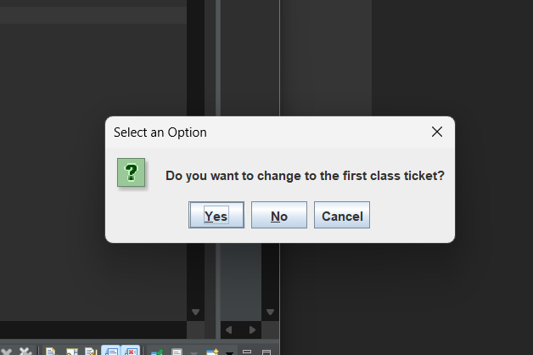

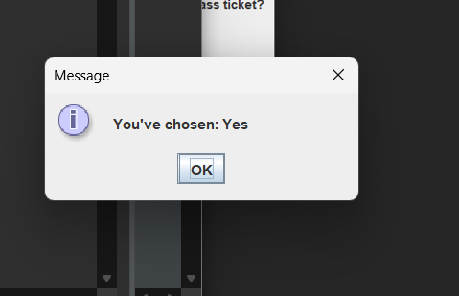

6.2

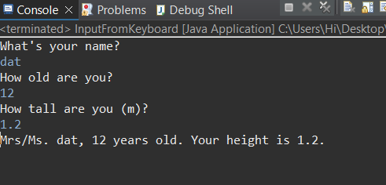

6.3

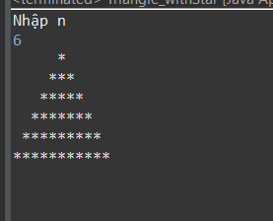

6.4

6.5

6.6

